Smart Fire Suppression System

By V Raj Narayanan

1. Introduction

Fire accidents are one of the most devastating and dangerous accident to occur in life causing both physical and psychological distress. Damage to important property and items.
This project helps take a step forward to help reduce this major issue.
The Smart Fire Suppression System (SFSS) detects fire and suppresses the fire using water pump and an IR flame sensor to detect the fire’s location.

2. Components

- Arduino UNO
- ESP32 Dev Board
- 2 servo motors
- IR Flame sensor
- Mini DC water pump
- Single channel relay module
- Power bank 5V
- 9V battery
- Jumper wires
- Breadboard
- Silicon tube
- Buzzer

3. Circuit Diagram
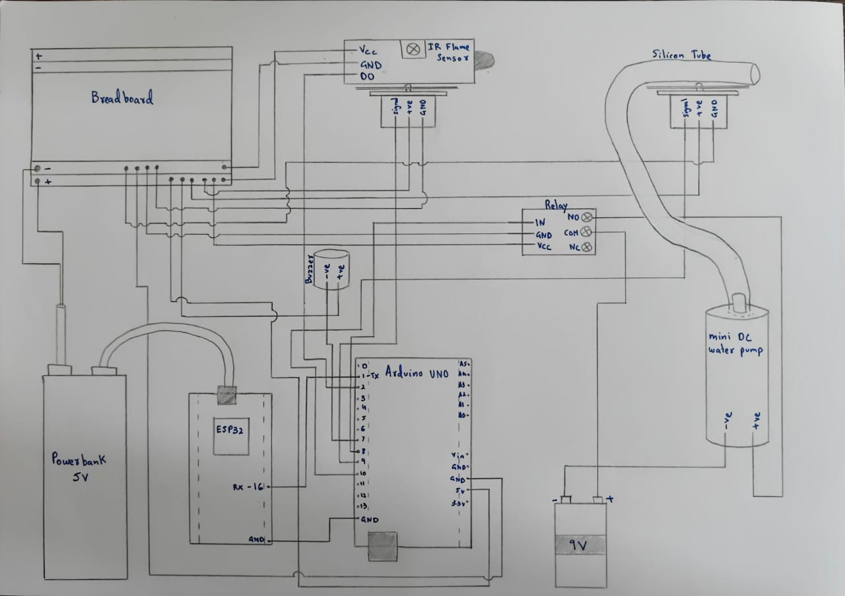

4. Code
ARDUINO CODE:
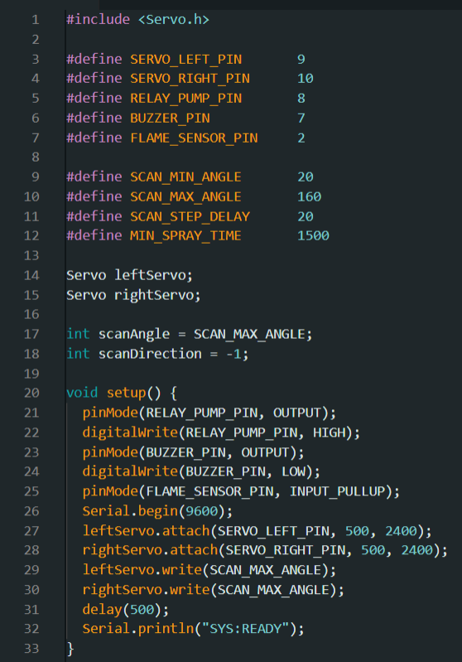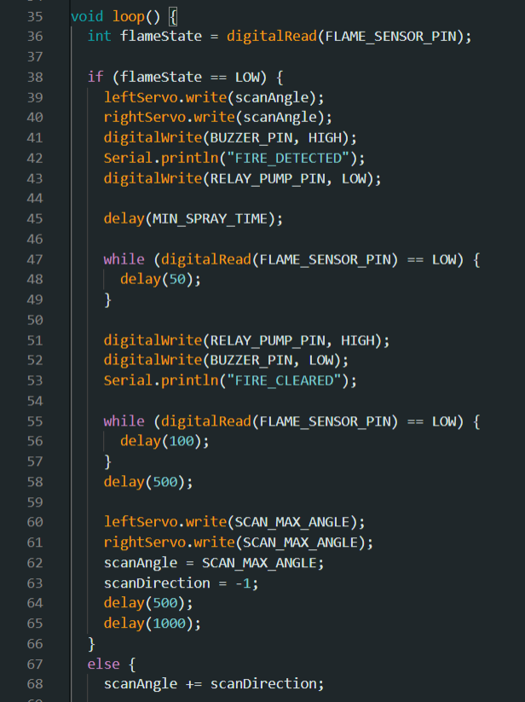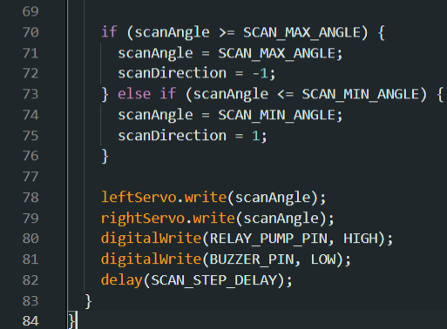

ESP32:
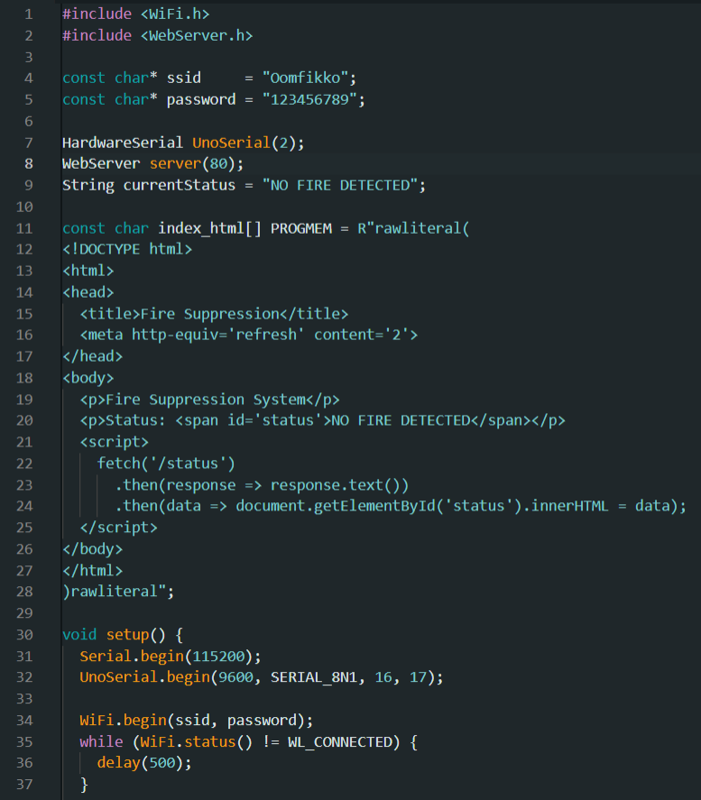
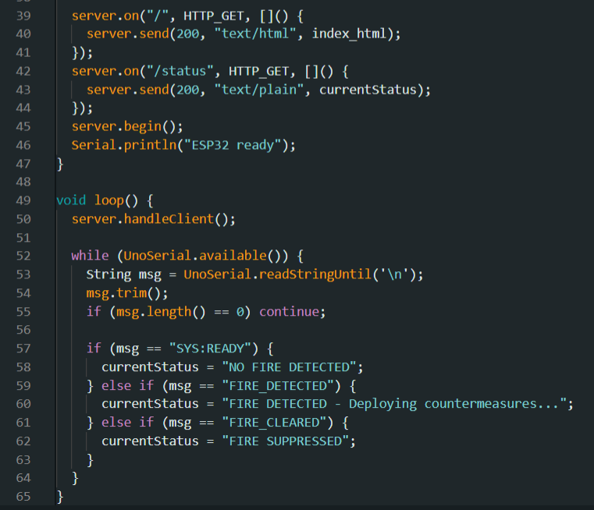

5. Pinout

Powerbank +Ve | Breadboard +Ve
Powerbank -Ve | Breadboard -Ve
Servo 1 +Ve | Breadboard +Ve
Servo 1 -Ve | Breadboard -Ve
Servo 2 +Ve | Breadboard +Ve
Servo 2 -Ve | Breadboard -Ve
Arduino UNO 5V | Breadboard +Ve
Arduino UNO GND | Breadboard -Ve
IR Flame Sensor Vcc | Breadboard +Ve
IR Flame Sensor GND | Breadboard -Ve
Relay Module Vcc | Breadboard +Ve
Relay Module GND | Breadboard -Ve
ESP32 Power | Powerbank 5V
Pump +Ve | Relay NO
Pump -Ve | 9V Battery -Ve
Relay COM | 9V Battery +Ve
Servo 1 Signal | Arduino UNO 9
Servo 2 Signal | Arduino UNO 10
Relay IN | Arduino UNO 9
Arduino UNO TX | ESP32 GPIO 16
IR Flame Sensor D0 | Arduino UNO 7
Arduino GND | ESP32 GND

6. Workflow

When the system is powered ON:
When a fire is not detected:
Both servos connected to silicon tube and Flame sensor
and start scanning the area 180°.
IR Flame sensor is turned ON and it searches for an active fire by sensing the IR radiation emitted by an active flame.
Relay is turned OFF (NO pin will not pass any voltage through)

When a fire is detected:
Both servos stop at the direction of the fire.
Flame sensor is turned OFF.
Buzzer will be turned ON.
Relay is turned ON (NO pin will pass through current)
through which water pump will be turned ON and water is
sprayed to the flame.
This project works on a dual power and dual microcontroller system.
A power bank with 5V is used to power the Arduino UNO, ESP32 Dev Board, 2 servos, the buzzer and the flame sensor through the breadboard.
And a separate 9V is used to power the mini-DC water pump and the single channel relay.
This is done as a single power source cannot provide enough current for the pump and the servos to work efficiently and in sync.
The Arduino UNO acts as the main control system for the physical controls and the ESP32 acts as a Wi-Fi output through which it will send data to the website which displays whether there is an active fire present or not.

7. Conclusion

The smart flame suppression system successfully demonstrates an automated approach to fire detection and response. It detects, pinpoints the direction and solves the crisis as intended.
Challenges faces:
- Using a single power source (2 cell lipo) did not work as intended as it did not provide enough current to run the servos and pump together.
- Could not use a single ESP to run the whole system as it would require a 3rd power source with 3.3V output as ESP32 only works efficiently on 3.3V.

